* **Body Parser:** it is a parser, it parse the request body that we get. We need this because by default req doesn’t parse the body. To install **npm install --save body-parser**

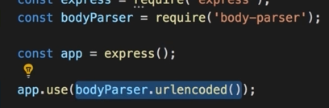

* **npm install --save ejs pug express-handlebars**  this is to install ejs + pug + handlebar. Even though im going to use ejs.